**DEPARTMENT OF VETERANS AFFAIRS**

**Veterans Health Administration**

**810 Vermont Avenue NW**

**Washington, D.C. 20420**

April 5, 2023

Re: Letter of support for W3C Solid-based federated query engine

I am writing to support for O.team to explore the implementation of a graph-based query engine based on the W3C Solid specification to enable federated query across

with the hopes that it could be used as a key infrastructure supporting personally-controlled healthcare ‘passport’ for Veterans. This capability would greatly improve privacy, portability, computability, fidelity, and re-usability of veteran health data across the continuum of care as veterans receive

The US Department of Veterans Affairs is devoted to finding ways to improve the quality

of medical care for Veterans by leveraging innovative technologies, and we believe we

have found a promising solution in Solid.

Solid is a semantic web specification enabling decentralized, personally controlled data platform for managing personal data developed by Sir Tim Berners-Lee, the inventor of the World Wide Web. It allows users to control their own data in their own Personal Online Datastore (Pod), which they can securely access and control from anywhere on the internet.

Medical partners of the VA can also join the system by having Pods of their own.

The US Department of Veterans Affairs uses Linked Data to manage the metadata of the 400+ million veteran-years of health data stored in the VA’s national healthcare information system. This foundation facilitates bidirectional interfacing to Linked Data-based Solid Pods. Once on Solid, Veterans will be able to control their healthcare records in their own Pods, which can be securely shared with their healthcare professionals.

One challenge we are facing is how to efficiently search through the massive

knowledge graph that would result from connecting all healthcare data in the VA into

one system. The Query Engine, as described by O.team in their submission for NSF

funding, would allow developers to efficiently search data using semantic queries, which

would greatly enhance the usability of the system.

Sincerely yours,

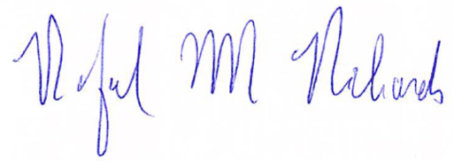

Rafael M Richards, MD MS FAMIA

*SME and Architect | Veteran Data Project*

*Informaticist | Office of Informatics and Analytics*

*Veterans Health Administration*

*U.S. Department of Veterans Affairs*